# CS 255 System Design Document Template

This template lays out all the different sections that you need to complete for Project Two. Each section has guidance to prompt your thinking. You will need to continually reference the interview transcript as you work to make sure that you are addressing your client’s needs. There is no required length for the final document. Instead the goal is to complete each section based on what your client’s needs are. Remove this note when you are finished, and replace all bracketed text with the relevant information.

## UML Diagrams

### UML Use Case Diagram

### UML Activity Diagrams

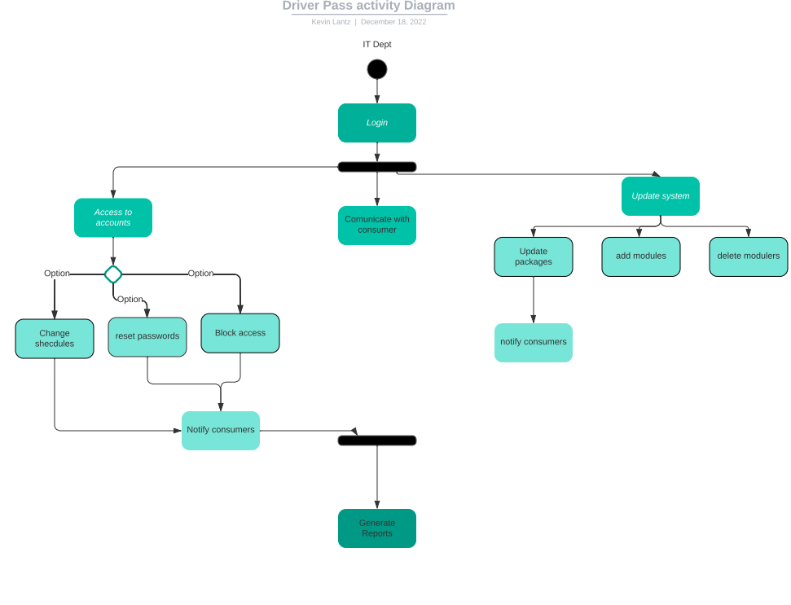

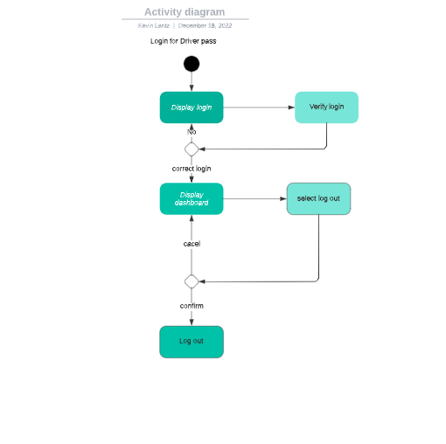

### UML Sequence Diagram

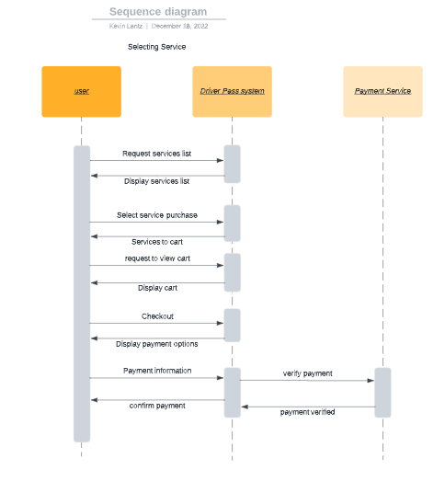

### UML Class Diagram

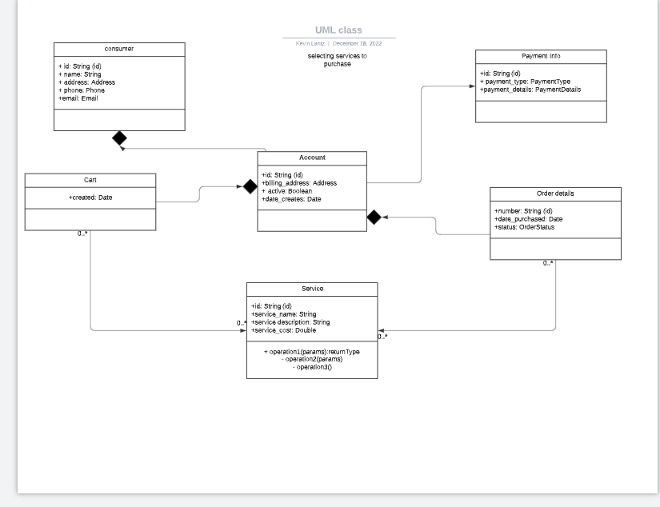

## Technical Requirements

* The system will be web based
* Be able to process the needs of the users
* Will be based in the cloud
* Must validate credentials before users can gain access
* Allow different package options
* Allow user to see a dashboard with progress
* Show users package options to purchase
* Allow instructor access to students profiles
* User must have internet access with all computer needs
* Customer will need modern applications and enough storage and memory to use DriverPass